**Experiment 1:** WAP to enter numbers till the user wants. At the end, it should display the count of positive, negative, and Zeroes entered.

**Solution:-**

**Code:-**

#include <stdio.h>

int main() {

int positive_count = 0;

int negative_count = 0;

int zero_count = 0;

float num;

while (1) {

printf("Enter a number (enter 0 to stop): ");

scanf("%f", &num);

if (num > 0) {

positive_count++;

} else if (num < 0) {

negative_count++;

} else {

zero_count++;

}

if (num == 0) {

break;

}

}

printf("Count of positive numbers: %d\n", positive_count);

printf("Count of negative numbers: %d\n", negative_count);

printf("Count of zeroes: %d\n", zero_count);

return 0;

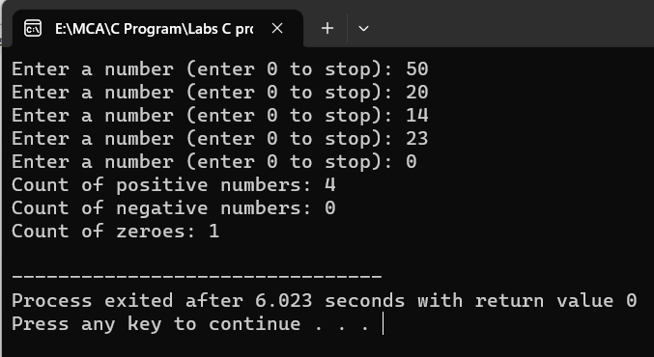}

**Output:-**

**Experiment 2:** WAP to print the multiplication table of the number entered by the user. It should be in the correct formatting.

 Num * 1 = Num

**Soultion:-**

**Code:-**

#include<stdio.h>

int main()

{

int num,i=1,t;

printf("enter the number to print the table ");

scanf("%d",&num);

while(i<=10)

{

t=num*i;

printf("%d*%d=%d\n",num,i,t);

i++;

}

return 0;

}

**Output:-**

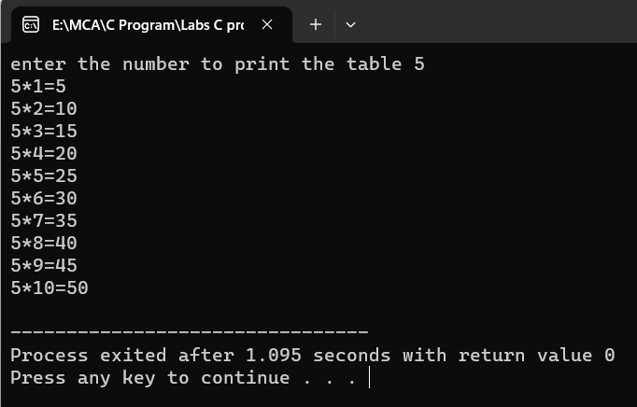

**Experiment 3:** WAP to generate the following set of output.

a.) b.)

1  1

2 3  1 1

4 5 6  1 2 1

 1 3 3 1

 1 4 6 4 1

**Solution:-**

Code:-

#include <stdio.h>

int main() {

    int n = 1;

//pattern 1

    for (int i = 1; i <= 3; i++)

      {

        for (int j = 1; j <= i; j++)

          {

            printf("%d ", n);

            n++;

        }

        printf("\n");

    }

//pattern 2

int numRows = 5;

    for (int i = 0; i < numRows; i++)

      {

        int num = 1;

        for (int j = 0; j <= i; j++)

         {

            printf("%d ", num);

            num = num * (i - j) / (j + 1);

        }

        printf("\n");

    }

    return 0;

}

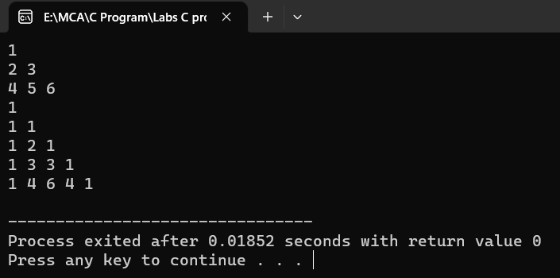

**Output:-**

**Experiment 4:** The population of a town is 100000. The population has increased steadily at the rate of 10% per year for the last 10 years. Write a program to determine the population at the end of each year in the last decade.

**Soultion:-**

**Code:-**

**#include <stdio.h>**

**int main()**

**{**

**int initial_population =100000;**

**int years=10;**

**double growth_rate=0.10;**

**int population=initial_population;**

**printf("Year\tPopulation\n");**

**for (int year = 1; year <= years; year++) {**

**population =population+(population * growth_rate);**

**printf("%d\t%d\n",year,population);**

**}**

**return 0;**

**}**

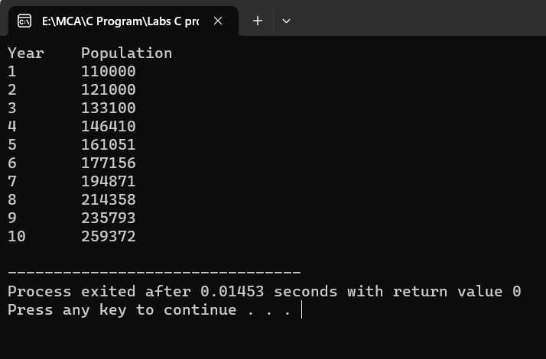**Output:-**

**Experiment 5:** Ramanujan Number is the smallest number that can be expressed as the sum of two cubes in two different ways. WAP to print all such numbers up to a reasonable limit.

Example of Ramanujan number: 1729

 12^3 + 1^3 and 10^3 + 9^3. for a number L=20(that is limit)

**Soltuion:-**

**Code:-**

#include <stdio.h>

int main()

{

long long limit = 20;

printf("Ramanujan Numbers up to %lld:\n", limit);

for (long long num = 1; num <= limit; num++)

{

int count = 0;

for (long long a = 1; a * a * a < num; a++) {

for (long long b = a; b * b * b < num; b++) {

if (a * a * a + b * b * b == num) {

if (count == 0) {

printf("%lld (%lld^3 + %lld^3)", num, a, b);

} else

{

printf(" and (%lld^3 + %lld^3)", a, b);

}

count++;

}

}

}

if (count > 1) {

printf("\n");

}

} return 0;

}

**Output:-**

